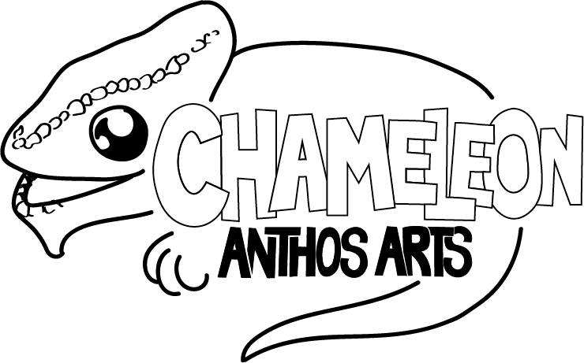
Anthos Arts Chaemeleons Project –
‘Thor & Loki in: The Missing Hammer’ Summer Term 2021

Applicant’s Details
Full Name
Date of Birth
Street Address
Town Postcode

Parent/Guardian(s) Contact Information
Full Name(s)
Street Address (leave blank if the same as above)
Town Postcode
Contact Numbers (Home/Phone)
E-Mail Address
Person to Notify in Case of Emergency and number (if different).

Rehearsals
This term will run from Saturday 1st May to Saturday 19th June at The Cygnet Theatre, Friar’s Gate, Exeter EX2 4AZ. Sessions shall take place from 10:30am-12:30pm (Please note; there will be a session on Sunday 23rd May, as a Saturday session is not possible this week).
This term the group shall be creating a recorded final performance, as a live production is still not possible within COVID 19 restrictions. This performance shall take place on Saturday 19th June and all participants must be available to attend the theatre from 9am. The total cost is £80 (£8 per session x 10 sessions).

Please list any dates between Saturday 1st May and Saturday 19th June where your child/children would be unable to attend.
I agree to a payment of £8 a session (£64 full payment)

Payment can be paid in full or two 50% payments of £32 via bank transfer to:

Anthos Arts
Account Number: 57329370
Sort Code: 600806

Alternatively, cheques to be made to Anthos Arts. Please contact us to discuss alternative payment methods/if you have any questions.

If you wish to play in two halves, then payments should be made by the following dates-

1st payment by Saturday 29th May.
2nd payment by Saturday 19th June.

Those paying in full must do so by Saturday 19th June.

PLEASE DO NOT MAKE ANY PAYMENT UNTIL SPACE IN THE GROUP HAS BEEN CONFIRMED.

Refunds
We will be offering refunds for any sessions cancelled due to a local/national lockdown or change in Tier rules which prevent the group from running, providing these sessions cannot be rescheduled.

Availability

Please note that, to make things fair, unexplained/unplanned absences not related to health during the previous term will be considered when reviewing applications. Additionally, to comply with social distancing guidelines, we shall be limiting the capacity of the Chameleon Group to 15 students per term.

Special Educational, Dietary and/or Health Considerations
Anthos Arts works hard to uphold and respect equal rights. If you have any special educational, dietary, and/or medical considerations that you believe will affect the participatory nature of Anthos Arts, and you feel are important to declare, please use the below box. This is so that we make sure measures are put in place and our young people are best supported during rehearsal times.
For the duration of these projects, our certified first aider will be Jake Celecia (or Emma Goulding in his absence).
If these change, please do get in touch with us: anthos-arts@outlook.com

Media/ photos/ videos
A part of Anthos Arts’ success has been our media attention. Please sign below to show that you are happy for us to photograph/video your child and that they can be a part of any media used within our publicity. Photos will not be taken/shared without parent’s permission.
I (parents/ guardians name)  ____________________________  allow my child (child’s name)  ____________________________  to be photographed and videoed for use by Anthos Arts publicity. | Parent/ guardians signature

Waiting List
Due to a high number of applications in previous terms, we now have a waiting list available for those interested in joining the Chameleon group. If you would like your child to go on the waiting list should they not receive a space, please state below:
I would like my child’s name to be added to the waiting list should a space not be available at the time of applying. Should a space become available, parents will be contacted by the email address given on the first page. | Yes/No

Agreement and Signature
By submitting this application, I affirm that the facts set forth in it are true and complete. I understand that if I am accepted as a member of Anthos Arts 2020/21, any important information that has not been disclosed is at my own liability.

Parent/Guardian(s) Name (Printed)
Signature
Date

This form should be completed and returned to: jake.anthos-arts@outlook.com . We will not be able to confirm a space unless we have a completed application form. If you have any difficulties submitting your form, please get in touch.

Thank you for filling out the application form.

